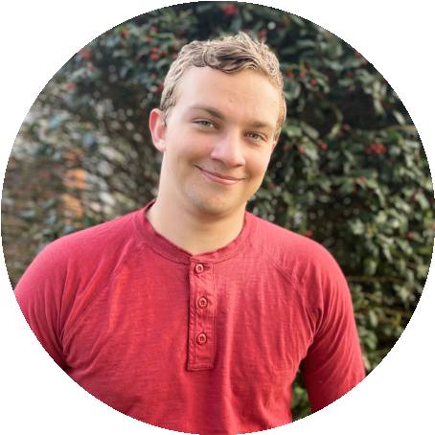
ISAAC HAMES

A
C
T
O
R
Accents

Writing

Improv

Teamwork

Singing
Time Management

S
K
I
L
L
S
912-532-0390
Oklahoma City, OK, 73179

isaachames17@gmail.com
reallygreatsite.com
I am an actor who will do what is necessary to bring a role to life. I have
been acting since kindergarten and am passionate about bringing
stories to life.

I use a Shure SM7B microphone with a Focusrite Scarlet
i2 interface.
2

P
R
O
F
I
L
E
E
X
P
E
R
I
E
N
C
E
Kolormix Studios: Directed by Ann Nicole
Romani Productions: Directed by Diego Muñoz
May 8th, 2022- Present
2021
ALDOHR IN "EXILED"
Paid Voice Acting
Recording accomplished in a single session
Utilized my British accent

WAITER IN "TRYING TO DANCE"
Paid role
Award-winning indie film
Live action
Cooperation
Gospel Publishing House: Directed by Dale Gehris
2012
MYRON IN "FAITH CASE: ARMOR OF GOD"
Paid film role
A nerd
Teamwork
E
D
U
C
A
T
I
O
N
University of Texas at El Paso
2020-2022
Bachelor’s in Communication

